Diwash Biswa, Drew McLaurin

Cpts 223

PA5 Report

10/26/18

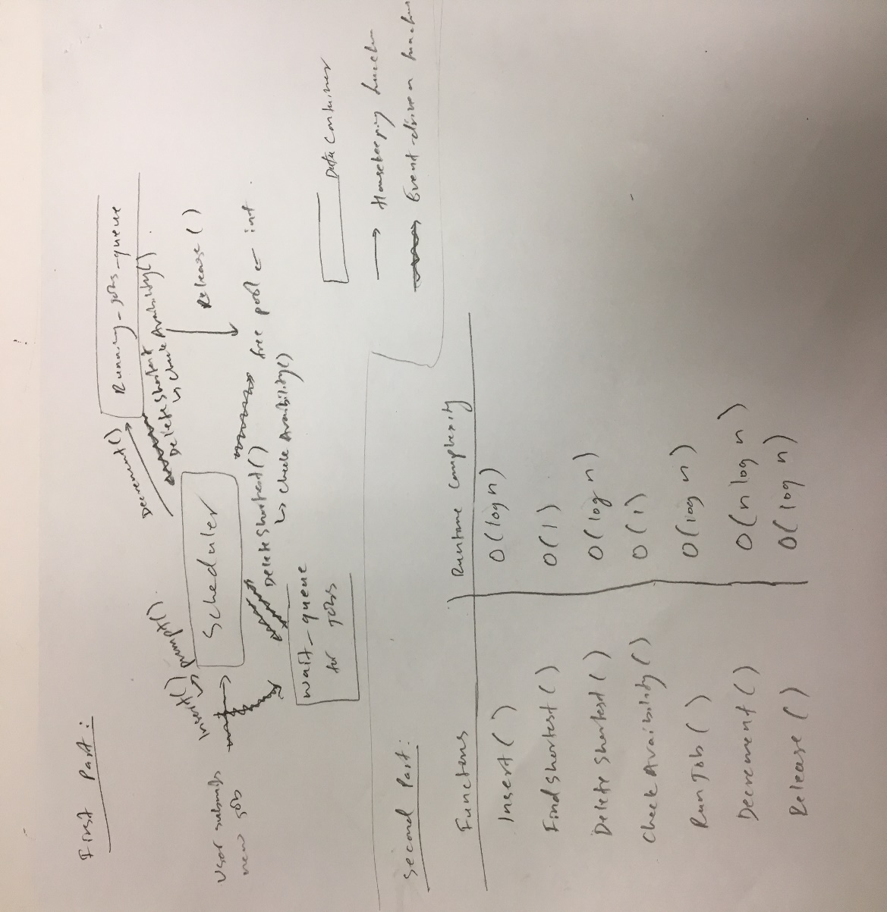PA5 Report

**Third Part:**

Overall, I think the shortest-job-first priority queue strategy worked very well in this program. It made accessing the shortest job easy because it was already at the front of the queue so we could just use the top() function to access the data. One negative aspect of the shortest-job-first queue is that the longest job sits at the back of the queue for a long period of time and will take a long time to access that job. There will always be side effects to using different priority methods for the queue.